Tealen Davis

Dr Sanders

ITEC 325 - 101

14 May 2023

# NAME OF PROCEDURE: Windows Server 2019

# PRINCIPLE

**The purpose of a Standard Operating Procedure (SOP) for Windows 10 Pro Installation is to provide the step-by-step process of configuring static IP setting for Windows Server 2019 using a sample IPv4 Address, Subnet Mask, and DNS. Configuring a static IP address can be useful in a variety of situations where network connectivity is important. For example, servers and network devices often require a consistent IP address for network communication. This is because they provide important services and resources to other devices on the network, and a change in IP address can cause disruptions in service. And in some cases, a potential source of connectivity problems could be caused by having a dynamic IP address as opposed to a static one. By configuring a static IP address, you ensure that these devices have a consistent address that can be easily accessed by other devices on the network So, let's get started!**

**Suppose that your static IP configuration is this:**

**IPv4 Address: 10.3.24.21**

**Subnet Mask: 255.0.0.0**

**DNS: 8.8.8.8**

**(practice static IP configuration with this)**

# SPECIMEN

# In a network setup known as a static IP address, a device or server is given a fixed, permanent IP address. If the IP address is not explicitly configured, it does not change. In contrast, dynamic IP address configuration is a network configuration where a device or a server is assigned an IP address automatically by a DHCP (Dynamic Host Configuration Protocol) server, which can change over time. Each type of IP config has its own unique purposes and is beneficial to use under specific circumstances. Laptops and smartphones often use dynamic IP addresses in order to allow the devices to switch to new networks whenever necessary.

# PROCEDURE

This tutorial could be used for upgrading your PC but also applies to installations that involve virtual machines. There are three main steps in OS installation in regards to virtual machines:

### Log in to your Windows Server 2019 with administrative privileges

### Open Network and Sharing Center from your Windows Server 2019 taskbar

## Open your Network and Sharing Center

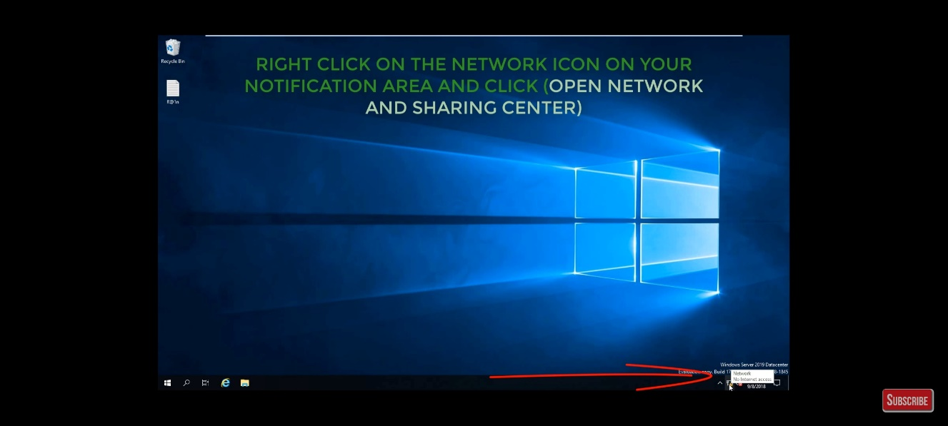

## In the Network and Sharing Center, click on the "Change adapter settings" option.

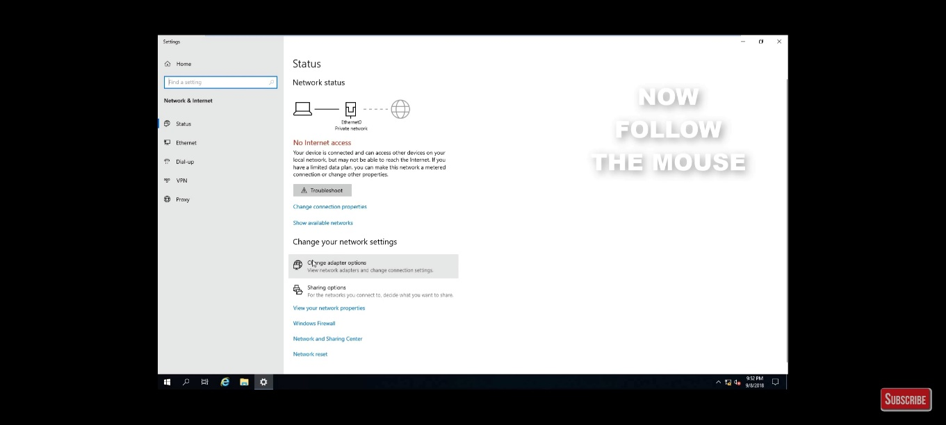

## Right-click on the network adapter that you want to set up with a static IP address and select "Properties".

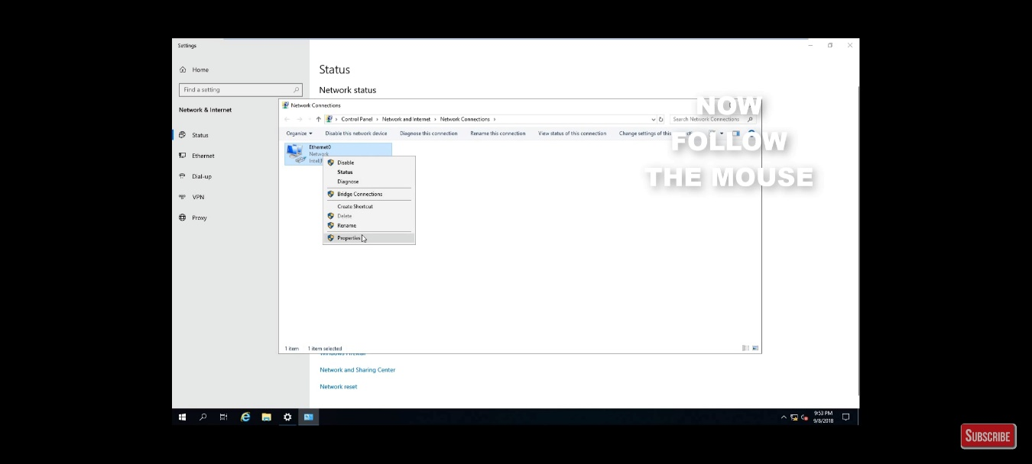

## Scroll down the list of items and locate "Internet Protocol Version 4 (TCP/IPv4)" and

## Right-click on the "Properties" button to open the Internet Protocol Version 4 (TCP/IPv4) Properties dialog box.

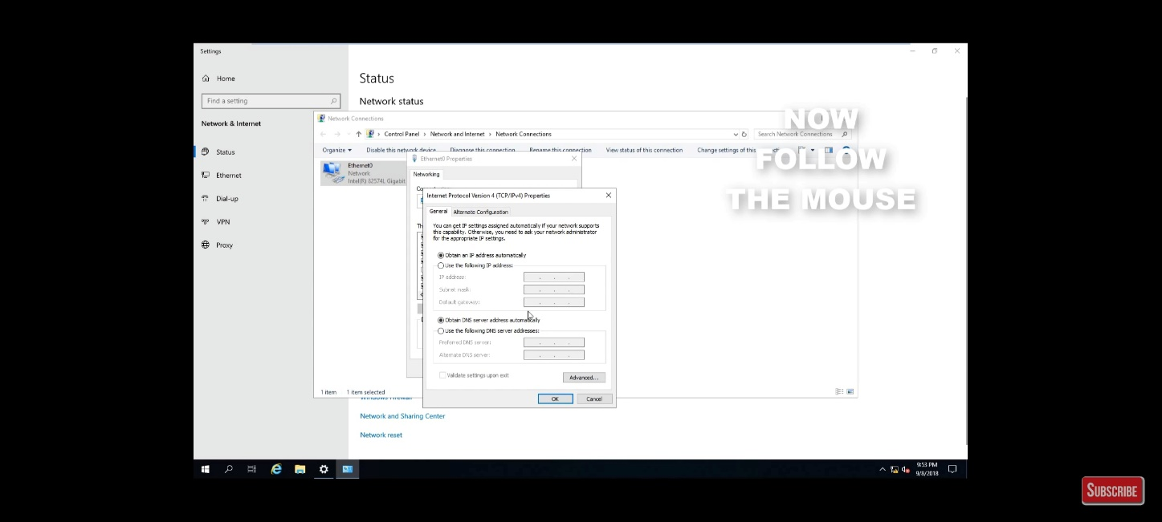

## In the "IP address", “Subnet mask”, and “Default gateway” fields, enter the IP address you want to use for the server and the network. Press “OK” to save your changes. You have now configured a static IP address. CONGRATULATIONS! 😊

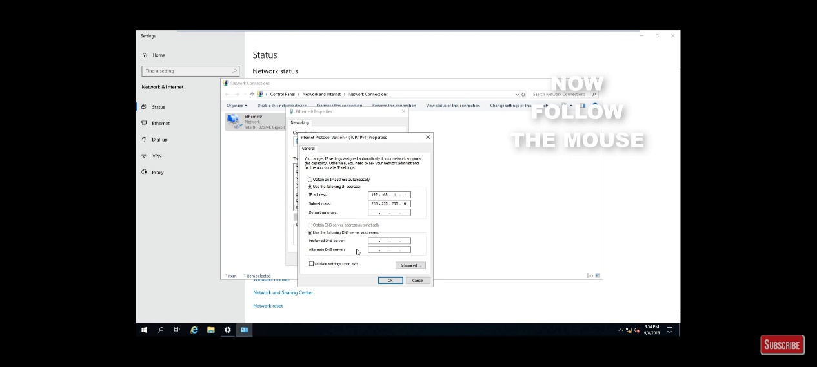

## To check your work, go to Windows Powershell and type ipconfig /all

